NBB IT Risk Compliance for Log360

**Tagline** – Streamline NBB IT Risk compliance and monitoring with Log360.
**Overview**
The NBB IT Risk Compliance extension for Log360 helps financial institutions align with the National Bank of Belgium's IT Risk framework. By integrating this extension, IT and security teams gain deep visibility into their IT risk posture and control effectiveness.
Log360 continuously collects and correlates log data from Active Directory, Windows, Unix/Linux, Microsoft 365, cloud platforms, and network devices, mapping events directly to NBB IT Risk standards. Security teams can track compliance status in real time, investigate incidents quickly, and generate audit-ready reports with a single click.

**Key Features:**
- Generate comprehensive audit-reports mapped to each of the NBB IT Risk requirements and controls.
- Generates real-time alerts for defined events, rule violations, and IT risk anomalies with multi-channel notifications.
- Provides powerful search capabilities with filters, keywords, and time-based queries for rapid incident investigation.
- Export reports in PDF and CSV format for auditors, management, or regulatory submissions.

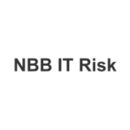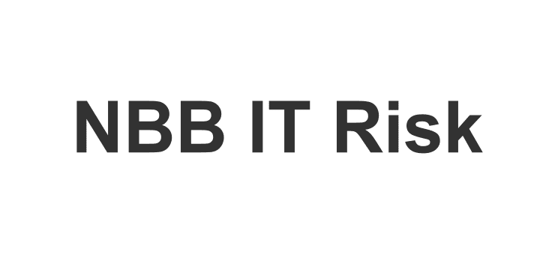

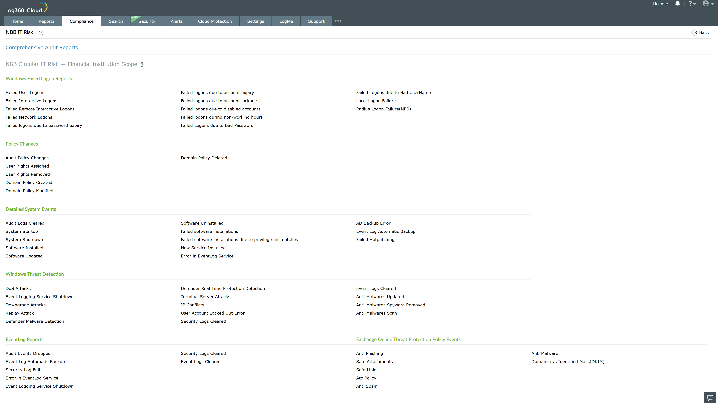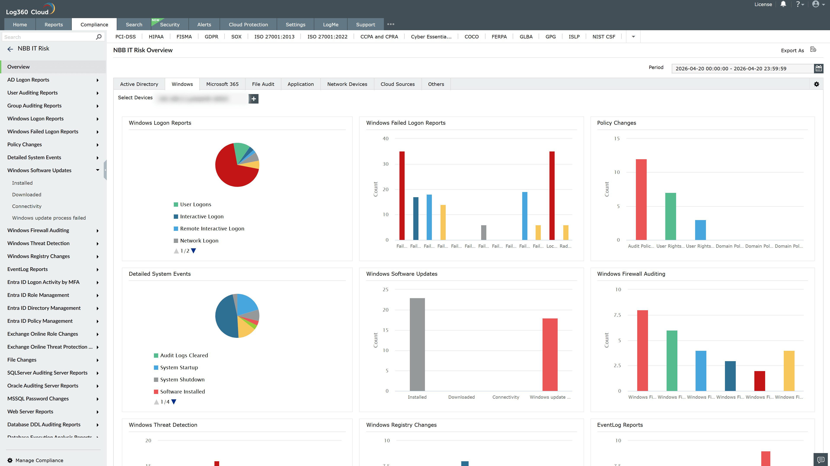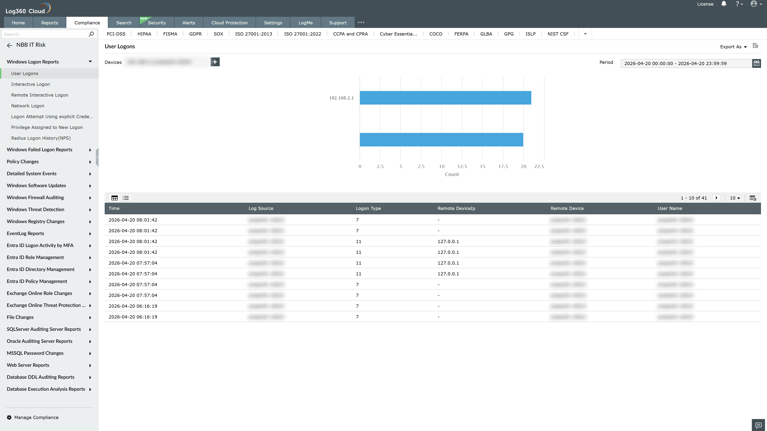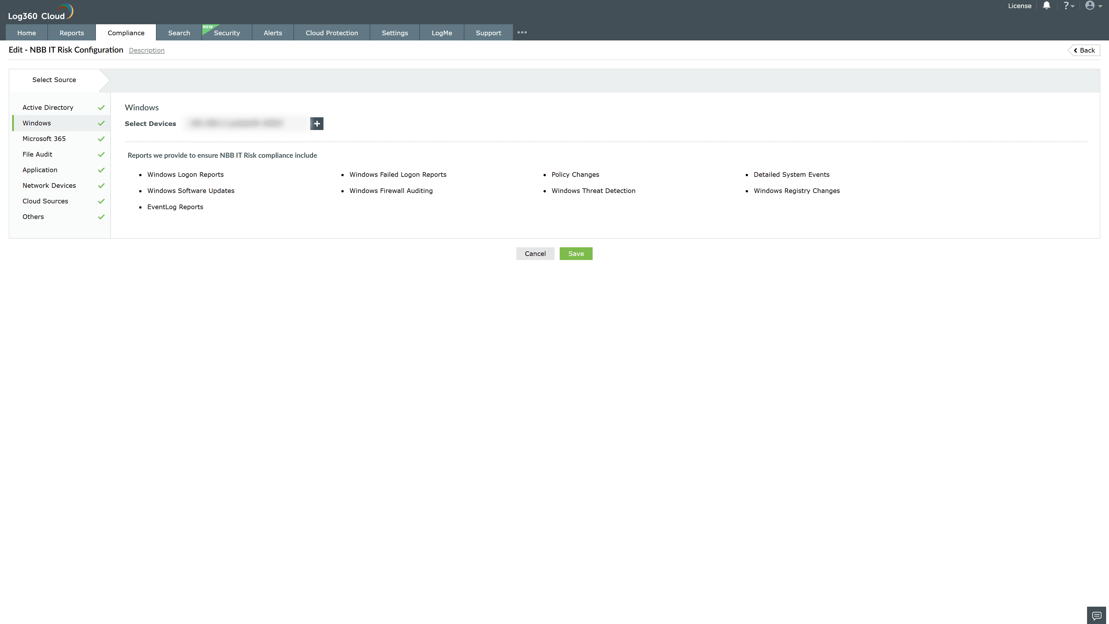
Valid Submission : Yes
Supported Editions : Free, Basic, Standard, Professional, MSSP
Help Document : https://www.manageengine.com/log-management/help/integrations/compliance-extensions.html
Help Video : Not provided
Tags : Log360, Compliance, Privacy monitoring, Data privacy, Regulatory compliance
Supported DCs : US, IN, JP, CA, AU, UK and EU
Privacy Policy:
Terms of Service:
Release Notes:
Predefined reports for the NBB IT Compliance.

